Graph 1: tenure and gender on enrollment

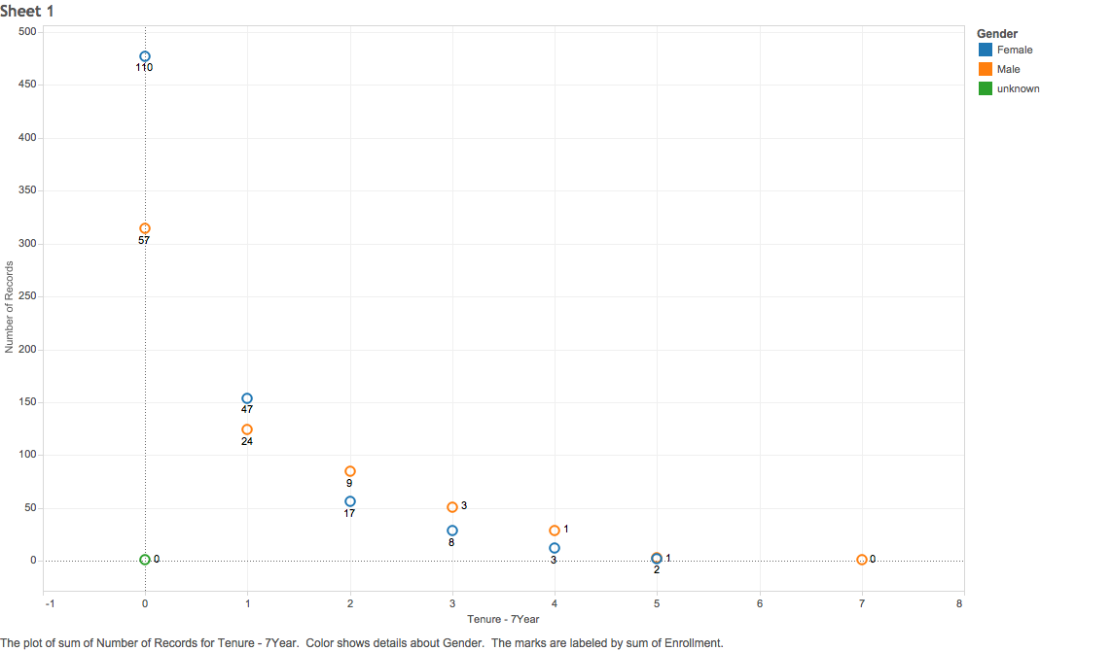

**Tenure (X-axis)**: Employees are categorized into 9 groups depends on how long they have been working for the company. Based on the standard deviation of the sample, each group is defined as a 7 years interval, which means people who have worked for 0 to 6 years are categorized as group 1.

**Number of records (Y-axis)**: The location of a dot indicates how many people are in each tenure category. The decreasing trend, especially the big drop between category 1 and category 2 shows the problem of high staff turnover rate.

**Gender (color)**: more female staffs are in the first 2 tenure categories, but the situation switched in category 3. So the turnover rate might be higher among women than men in the long run.

**Enrollment (number)**: the number below each dot is the amount of people who are enrolled in at least one online class. The enrollment number should be proportion to the amount of people in each category, both in the tenure and gender group. In other words, if a dot is higher than others, it is supposed to have a higher enrollment number as well. However, in tenure group 2, 3, and 4 the trend, proportionally speaking, male employees are less willing to enroll in classes compared to female employees.

Graph 2: Pay Scale on enrollment

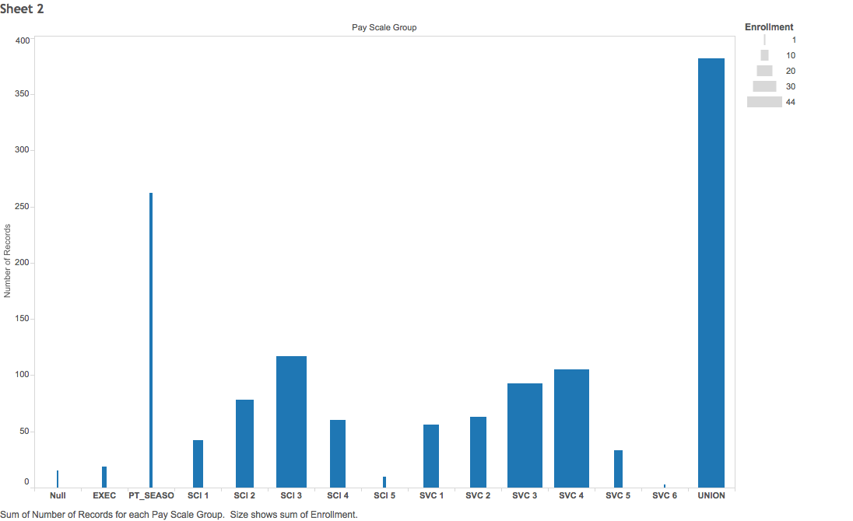

**Pay Scale (X-axis):** pay level

**Number of records (Y-axis):** indicates the total number of employees who are paid in each pay scale group.

**Enrollment (thickness)**: the thickness of each bar shows the amount of people who are enrolled in at least one online class. The thicker the bar, the more enrollment within that pay scale category. The thickness of each bar is generally proportion to its height, except seasonal employees who may not have access to online platform, and union worker group that is under-enrolled.

Graph 3: Region on enrollment

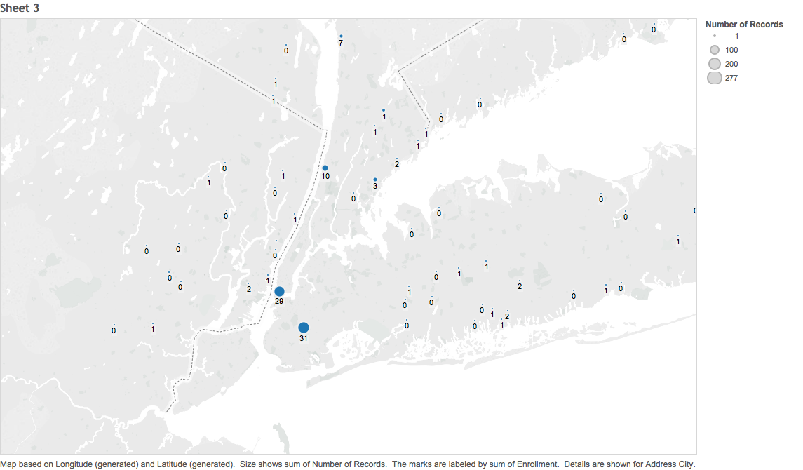

**Number of records (size)**: the size of a dot represents the amount of employees are from this region (city).

**Enrollment (number):** The number below each dot is the enrollment number. The bigger the dot, the bigger the number should be.